

ESCUELA DE EDUCACIÓN BÁSICA
CORPORACIÓN PEDAGÓGICA LÍDERES

MICROCURRICULAR PLANNING BY SPECIFIC AND GENERIC COMPETENCIES
School Name:
Academic Year:

1. INFORMATIVE DATA
Teacher: |  | Department:  English as a Foreign Language |  |  | Grade / Course:  4th EGB | Class:
Book:  New Leaders - Student’s book and workbook 4 | Unit 5  AT THE MARKET  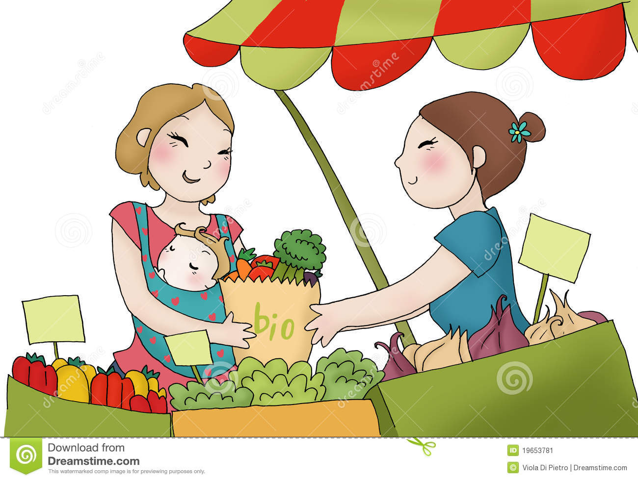 |  | OBJECTIVES  O.EFL 2.1 Identify some main ideas and details of written texts, in order to develop an approach of critical inquiry to written and oral texts.  O.EFL 2.2 Assess and appreciate English as an international language, as well as the five aspects of English that contribute to communicative competence.  O.EFL 2.3 Independently read level-appropriate texts in English for pure enjoyment/entertainment and to access information.  O.EFL 2.4 Develop creative and critical thinking skills to foster problem-solving and independent learning using both spoken and written English.  O.EFL 2.5 Use in-class library resources and explore the use of ICT to enrich competencies in the four skills.  O.EFL 2.6 Write short descriptive and informative texts and use them as a means of communication and written expression of thought.  O.EFL 2.7 Appreciate the use of English language through spoken and written literary texts such as poems, rhymes, chants, riddles and songs, in order to foster imagination, curiosity and memory, while developing a taste for literature.  O.EFL 2.8 Demonstrate a living relationship with the English language through interaction with written and spoken texts, in order to explore creative writing as an outlet to personal expression.  O.EFL 2.9 Be able to interact in English in a simple way using basic expressions and short phrases in familiar contexts to satisfy needs of a concrete type, provided others talk slowly and clearly and are prepared to help.
Periods: 18, 6 class periods per lesson |  |  |  | Weeks: 6
2. UNIT PLAN
Specific and Generic Competencies |  | Evaluation Criteria
Communication and Cultural Awareness  EFL 2.1.1 Exchange basic introductions and limited personal information in class using simple present tense in order to get to know their peers. (Example: where one lives or goes to school, etc.)  EFL 2.1.2 Recognize the differences between where people live among the regions of the country in order to appreciate their own environment. (Example: house/apartment, country/city, etc.)  EFL 2.1.4 Express curiosity about the world and other cultures by asking simple WH- questions in class after reading and/or participating in presentations or other group work.  EFL 2.1.6 Understand and use common expressions of politeness in class while working in pairs or groups on projects. (Example: please, sorry, thank you, etc.) EFL 2.1.7 Collaborate in a friendly manner by sharing classroom materials and personal objects while participating in games and activities in class and on the playground. |  | CE.EFL.2.1. Differentiate between different living situations in a variety of surroundings and express curiosity about the world through simple questions  CE.EFL.2.2. Catalog everyday objects and places in different cultures and recognize ways to act responsibly towards one’s environment and surroundings.  CE.EFL.2.3. Make use of basic personal information and expressions of politeness in order to introduce oneself and participate in a short conversation.  CE.EFL.2.4. Develop skills of collaboration by working together on projects and sharing materials while expressing personal preferences with peers.
Oral Communication  EFL 2.2.1 Understand meanings expressed in short dialogues on familiar topics, as well as basic spoken instructions and simple questions about self, people, animals or things, especially when spoken slowly and clearly. (Example: greetings, short phrases, basic range of classroom instructions, common personal information questions: What’s your name? How old are you? Where do you live? etc.)  EFL 2.2.3 Recognize familiar names, words, and short phrases about simple everyday topics whether heard in isolation or within short, simple spoken texts describing people and objects. (Example: vocabulary about self, family, friends and immediate surroundings at school and home, adjectives for color and size, etc.)  EFL 2.2.4 Identify items of specific information within simple messages or from short and simple descriptions about familiar contexts, especially if visual support is provided. (Example: letters of the alphabet, numbers, prices and times, days, dates and months, etc.)  EFL 2.2.6 Enjoy extensive listening in English. (Example: listen to stories, watch short movies, experience song lyrics or poetry, etc.)  EFL 2.2.10 Clap, move, chant or sing along with short authentic English language rhymes or songs, approximating English rhythm and intonation once familiar with the text. (Example: jump or clap in time to jump-rope rhymes, do the actions to action songs or short rhythmic poems, enunciating some of words in time with the rhythm, etc.  EFL 2.2.13 Understand and use basic greetings, leave-taking expressions, and other simple everyday phrases to facilitate interpersonal interaction, to introduce others, and to name things. (Example: Thank-you, Can I help you? This is [name]. It’s a [item], etc.) |  | CE.EFL.2.6. Listening for Meaning: Understand the main ideas in short simple spoken texts that include familiar vocabulary and are set in everyday contexts.  CE.EFL.2.7. Listening for Information: Follow short and simple spoken texts that include familiar vocabulary and are set in everyday contexts. Identify key items of information within the text, and record or act upon them.  CE.EFL.2.8. Production - Pronunciation: Produce individual words and short phrases clearly enough that other people can usually understand them easily.
Reading  EFL 2.3.1 Demonstrate basic reading comprehension skills by identifying the meaning of individual words, phrases, and sentences, including simple written instructions. EFL 2.3.2 Read a short simple text (online or print) and demonstrate understanding of the gist and some basic details of the content.  EFL 2.3.4 Understand the content in simple short written environmental print text types, using artwork, symbols and layout for support. (Example: price tags, signs, notices (No eating, etc.), candy wrappers, etc.)  EFL 2.3.5 Show the ability to use a simple learning resource. (Example: a small set of flashcards, a picture-based dictionary (online or print), or a simple word list).  EFL 2.3.6 Understand the content of a simple graphic organizer (online or print). (Example, Venn Diagrams, charts, and labeled diagrams.)  EFL 2.3.7 Read and understand the main ideas in a short simple text on a cross-curricular topic. (Example: art, music, history, etc.)  EFL 2.3.10 Read a variety of simple text-types and graphic organizers used to present cross-curricular information (Example: instructions, graphs, diagrams, charts, plans or maps, etc.) |  | CE.EFL.2.11. Identify and understand individual every-day words, phrases, and sentences, including instructions.  CE.EFL.2.13. Understand the content in a variety of well-known text types, both print and online, using the layout and artwork for support; recognize typical signs and symbols found in the text types.  CE.EFL.2.15. Learn to read graphs, diagrams, charts, and other kinds of graphic organizer. Demonstrate understanding of a text presented in the form of a graphic organizer (both print and digital).
Writing  EFL 2.4.1 Know how to spell simple English words correctly, demonstrating awareness of sound-letter relationships. (Example: sea, mean, bee, etc.)  EFL 2.4.3 Write simple words, phrases and sentences with correct use of standard writing mechanics. (Example: spelling, punctuation, capitalization, and writing by hand and/or on the computer.  EFL 2.4.4 Write simple words, phrases and sentences for controlled practice of language items.  EFL 2.4.5 Write simple sentences on familiar topics to communicate basic ideas.  EFL 2.4.6 Write a short simple paragraph to convey some simple facts about people, animals, places, things, yourself or others, with the support of a model text. (Example: where they live, what they do, etc.)  EFL 2.4.8 Complete a basic survey or a questionnaire by providing personal details. |  | CE.EFL.2.17. Write simple words, phrases, and sentences to demonstrate knowledge of spelling, punctuation, capitalization and handwriting / typography, and identify their meanings.  CE.EFL.2.18. Writing in order to perform controlled practice of vocabulary and grammar items.
Language through the Arts  EFL 2.5.1 Identify key information such as events, characters, and objects in stories and other age-appropriate literary texts if there is visual support.  EFL 2.5.2 Express emotions and feelings using basic adjectives and related images through written work on the school or class bulletin board.  EFL 2.5.6 Generate and expand ideas by responding in a fun and playful manner to oral and written texts in order to increase enjoyment of the language through TPR, playground games, and songs and chants. |  | CE.EFL.2.21. Distinguish key information in stories and other age-appropriate literary texts, both oral and written.  CE.EFL.2.22. Describe and write about emotions and responses to literary texts through words and images, or other media (video, audio) on class or school bulletin boards and expand on ideas and responses to texts read/seen/heard in by participating in songs/chants, TPR activities and playground games.  CE.EFL.2.25. Implement a range of creative thinking skills to show a respect for sharing and accepting different ideas in brainstorms and pair work.
Methodological Strategies | Resources | Evaluation Indicators | Evaluation: Activities / Techniques / Instruments
Communication and Cultural Awareness  Talking about the importance of eating healthy food.  Asking about your favorite fruit and vegetables.  Singing songs that practice helpful language about fruit and vegetables.  Oral Communication: (Listening and Speaking)  Identifying different fruit and vegetables.  Talking about likes and dislikes.  Structures: "What fruit do you like (to eat)?", I love/ I like ..., I don’t like/ I hate + Noun or Verb +ing.  Example: I like bananas.  I like eating banana.  Establishing a clear expectation of English use during the classroom. (Example: greeting, requesting, thanking, asking for repetition / clarification, giving instructions, offering help, comparing answers, taking leave, etc.) Informal assessment could involve personal notes from the teacher to learners who use L2 regularly.  Talking about likes and dislikes about food. Students sing a song about food, I like ~", "I don't like~", "What a stink!"  Reading  Reading Yes/No questions in present continuous and choose some short answers. Ex: Is Anna eating soup?  Yes, she is. / No, she isn’t.  Reading a text and answering information questions using colors and prepositions of place: Next to, between, over, under, in, on. Choosing from a list of words to complete gaps from a reading  Writing  Writing about the food you like and choose words for a glossary and writing sentences.  Identifying the format of a familiar text-type and using it as a model for your own writing. (Example: Text-type: Recipe. Format: Ingredients, Preparation, etc.)  Language through the Arts  Creating a crossword puzzle in groups about Ecuadorian food.  Creating a dance for a popular song or rhyme.  Participating in TPR activities such as acting out situations in a story as it is read aloud. | New Curriculum EFL for Media EGB  New Leaders - Student’s book and workbook 4  Flash Cards from 89 to 90  Activity Book  (AB79 – AB88)  colored crayons  - plastic fruit (in a small box)  - a length of rope  - real fruit, cut up into small pieces  - CD / Tape player / Computer or something to play the song on  supermarket magazines (with lots of food and drink pictures) | Communication and Cultural Awareness  I.EFL.2.1.1. Learners can recognize differences between where people live and write or talk about their own surroundings, as well as ask questions about how other people live. (I.2, S.2)  I.EFL.2.2.1. Learners can classify everyday objects and familiar places. Learners can compare objects from different cultural contexts. Learners can say and recognize ways to take care of the environment and one’s surroundings. (J.3, S.1)  I.EFL.2.3.1. Learners can use basic personal information and expressions of politeness in short dialogues or conversations. (J.2, J.3)  I.EFL.2.4.1. Learners can select pictures and/or short phrases that relate to collaborating and sharing and express personal preferences. (J.2, J.3, S.4)  Oral Communication  I.EFL.2.6.1. Learners can understand the main ideas in short simple spoken texts and infer who is speaking and what the situation is, without decoding every word. (I.3)  I.EFL.2.7.1. Learners can understand short and simple spoken texts well enough to be able to pick out key items of information and record them in writing or drawings, or physically act upon them. (I.3)  I.EFL.2.8.1. Learners can pronounce most familiar vocabulary items accurately, and can therefore usually be easily understood. They can also produce some phrases and short sentences clearly, and may approximate English rhythm and intonation in longer utterances. (I.3)  I.EFL.2.9.1. Learners can express basic ideas, initiate conversations, and respond to simple questions using appropriate words, phrases, and short sentences. Responses may be slow though pauses do not make the interaction tedious or uncomfortable for participants. (I.3)  Reading  I.EFL.2.11.1. Learners can understand familiar words, phrases, and short simple sentences and can successfully complete the simple accompanying task. (I.4)  I.EFL.2.12.1. Learners can understand a short simple text on an everyday topic and successfully complete a simple task to show that they have understood most or some of it. (I.4)  I.EFL.2.13.1. Learners can understand a short simple environmental print text type and successfully complete a simple task. (Example: a sign, notice, menu, etc.) (I.3)  I.EFL.2.15.1. Learners can use simple graphic organizers to show that they can understand a short simple text. (Example: maps, diagrams, bar charts, Venn diagrams, etc.) (I.4)  Writing  I.EFL.2.17.1. Learners can write words, phrases, and short simple sentences using the correct conventions (spelling, punctuation, capitalization, and handwriting or typography, etc.), for making simple learning resources. (I.3)  I.EFL.2.18.1. Learners can write short simple phrases and sentences to show that they know how to use simple grammar or vocabulary items. (I.3, I.4)  Language through the arts  I.EFL.2.21.1. Learners can recognize, through pictures or other media such as ICT, key aspects of a story or literary text (both oral and written). (J.1, I.2)  I.EFL.2.22.1. Learners can report emotions and compose short responses to literary texts through words and images, or other media (video, audio). Learners can generate and expand on personal opinions and responses to oral and written texts through TPR, playground games, and songs. (I.3, S.3) | ACTIVITIES and TECHNIQUES  Establish a clear expectation of English use for classroom functions.  Read a text and matching content-based words to their right position using more prepositions of place.  Complete gaps from a reading using words from a box about fruit and vegetables.  Illustrate a piece of writing about the food you like or dislike.  Look at the pictures and complete specific information while answering Yes/No and Wh- questions.  Collage  You will make a collage about likes and dislikes for food  INSTRUMENTS  Picture-based test  ▪ Rubrics  ▪ Vocabulary Quilt  ▪ Mind Maps  ▪ Oral interviews individual/ in pairs  ▪ Practical Exams.  ▪ Writing Tests  - Free unit project  (Be creative)

INSERTION: Civic Education, Ethics, and Integrity (Community roles and active citizenship)

Topic: My Community & Citizenship (Roles and Responsibilities)
- Skills: Identifying community helpers (e.g., doctor, police officer, firefighter, teacher), describing their roles and responsibilities, asking and answering "What does a [community helper] do?", understanding rules for being a good citizen.
- Objective: Students will be able to identify key community helpers, describe their functions, and understand their own roles and responsibilities as active and ethical members of their community.
- Evaluation Indicators:
  - Names at least 5 community helpers and their main duties.
  - Asks and answers questions about community helper jobs.
  - States 2-3 ways they can be a good citizen at school or home.
  - Participates in a "Community Helpers Day" role-play.
- UDL Application: DUA
  - Representation: Videos of community helpers in action, guest speakers (if possible), picture books about different jobs, diagrams of community structures.
  - Action & Expression: Drawing a "Community Map" with different helpers, writing thank-you notes to school staff, creating a "Good Citizen" checklist.
  - Engagement: "Community Helper Dress-Up," "Job Interview" role-play, a "Community Service Project" (e.g., cleaning up the playground).

3. ADAPTED CURRICULUM
- Approach: UDL (Universal Design for Learning) DUA
• Multiple Means of Representation: Videos, infographics, readings, etc.
• Multiple Means of Action/Expression: Oral, written, visual tasks.
• Multiple Means of Engagement: Games, teamwork, real-world projects

CLIL Components - Science/Technology/Arts: |  |  | Transversal Axes  Intercultural awareness, tolerance, respect, multiculturalism, responsibility, solidarity, responsibility, honesty, respect, love, peace, justice, innovation, etc.
Done by | Checked by |  |  | Approved by
Teacher: | Teacher: |  |  | Teacher:
Signature: | Signature: |  |  | Signature:
Date: | Date: |  |  | Date:

